Hello World Login Test
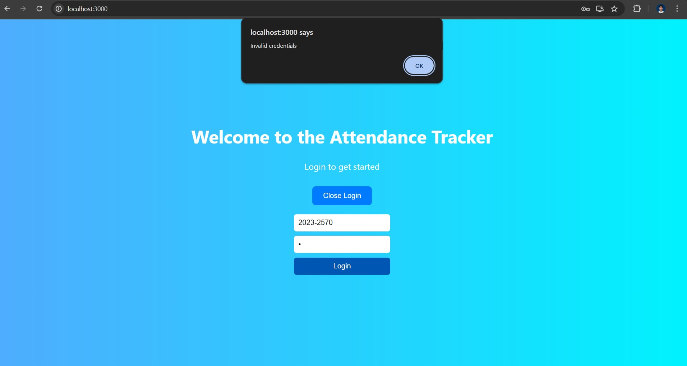
Web Login with Unregistered User
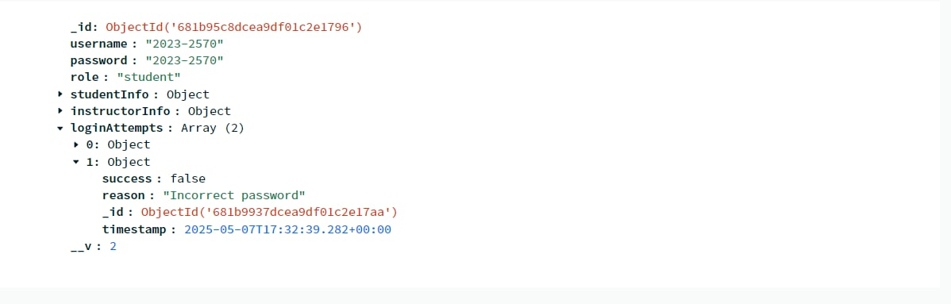
Database

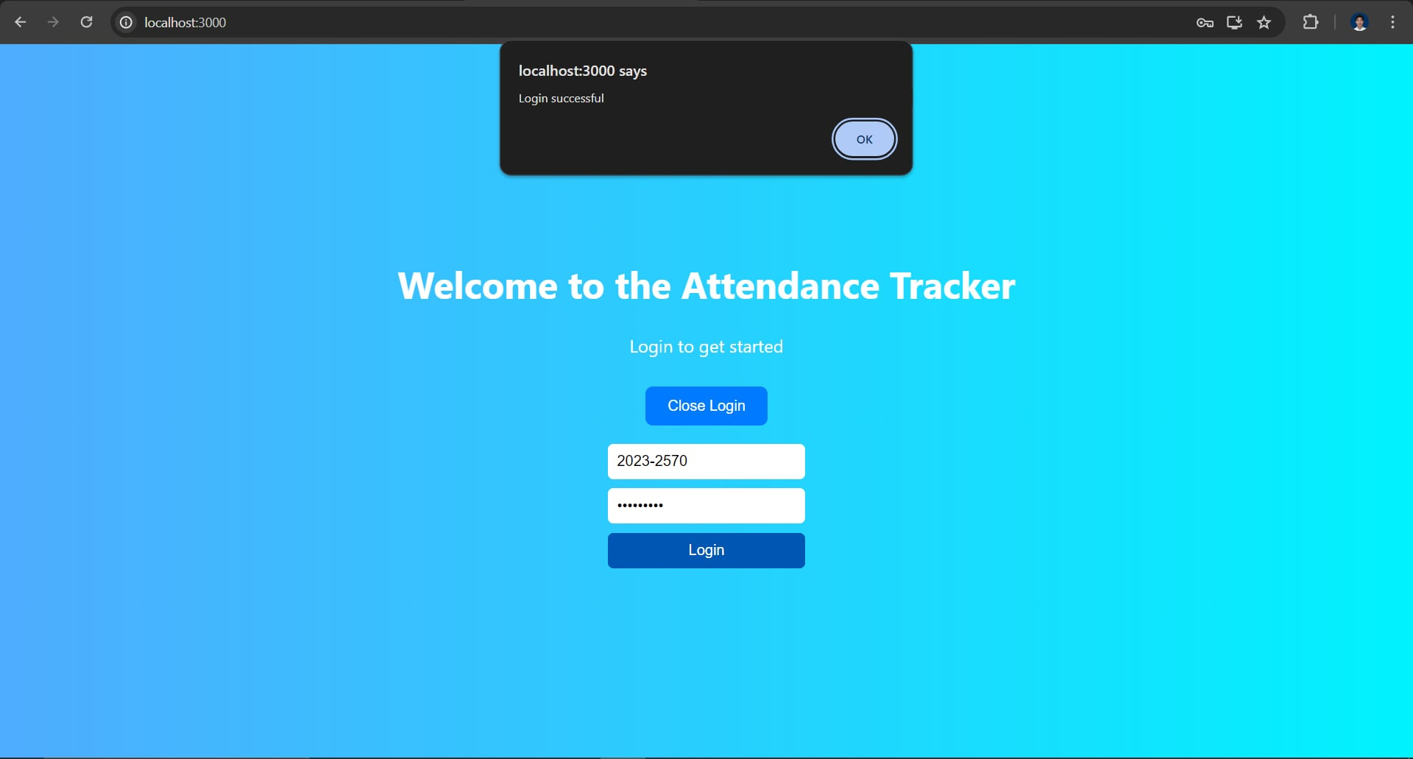
Web Login with Registered User

Database
